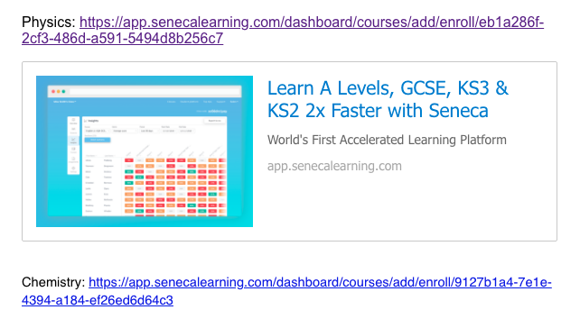

**Physics and Chemistry A Level revision links**