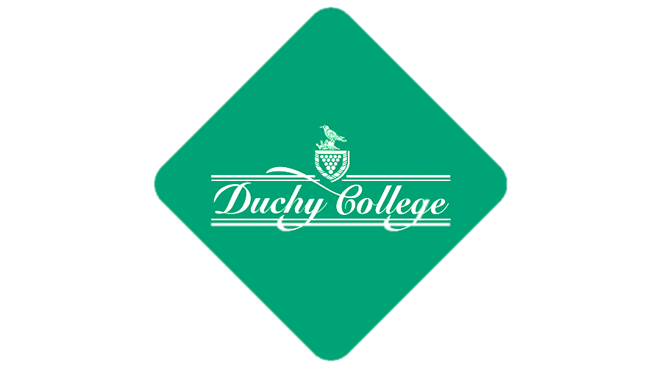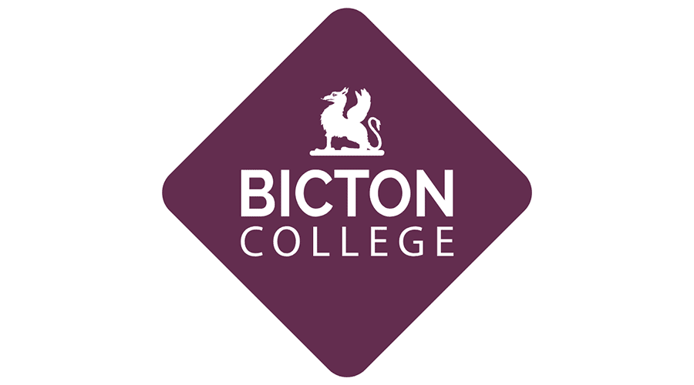

Duchy college foundation learning - <https://www.facebook.com/duchycollegeskillsforlife/>

Bicton College Foundation Learning - <https://www.facebook.com/FLBicton/>

Equine  - <https://www.facebook.com/bictoncollege.equestriancentre/> or <https://www.facebook.com/stokeclimslandcampus/>

Military & Protective Services Academy - <https://www.facebook.com/Duchycollegemilitaryacademy/>

Sport, Adventure Sport and Fitness - <https://www.facebook.com/staustellfitness/> and <https://www.facebook.com/Duchysportsandoutdooradventure/>